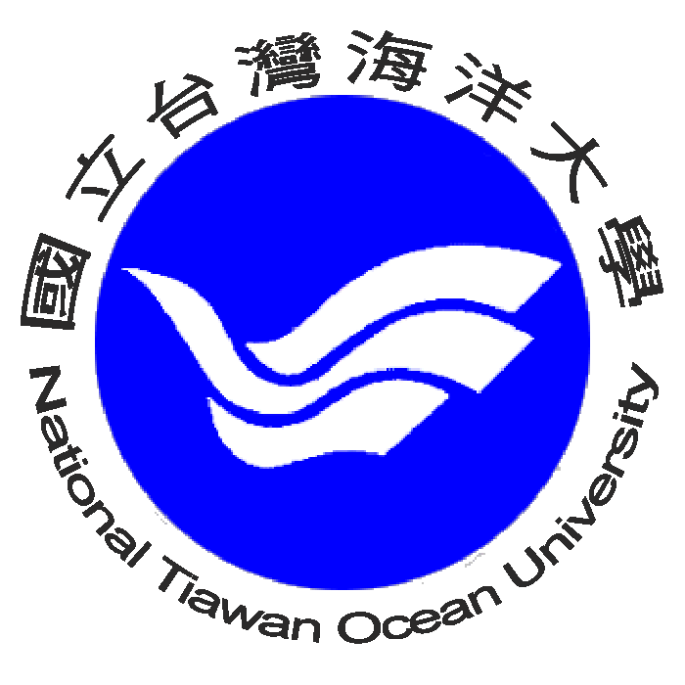
National Taiwan Ocean University

No. 2 Beining Rd., Jhongjheng District, Keelung city 202, Taiwan (R.O.C)
Tel: +886-2-2462-2192, Fax: +886-2-2462-0724

-----------------------------------------------------------

Keelung city, April 2014

LETTER OF RECOMMENDATION

To whom it may concern,
I would like to recommend Mr. Vu Dinh Trung to be a great candidate for NTOU scholarship.
During his time in my laboratory, Mr. Trung has demonstrated that he is one of the best and promising young students at our department with very good background of multimedia, organizing independent creativity capacity. Additionally, I can see he has participated actively in many extra-curricular activities. Lastly, he can use English effectively in his study.
I do strongly recommend Mr. Trung is on the right direction for higher education at National Taiwan Ocean University, Taiwan.

Yours sincerely,

Prof. Jim Zone Chang Lai, PhD
Department of Computer Science and Engineering
National Taiwan Ocean University

